**Portafolio optimization project**

**Monte Carlo Simulation Applied to Markowitz Portfolio Theory**

**Mijail Dragowski**

**2023**

**Introduccion**

The objective of this project is to carry out an optimization of a portfolio made up of 4 stocks according to the criteria of Markowitz Portfolio Theory. The strategy chosen for this objective will be to carry out a Monte Carlo simulation. With this technique, 500,000 simulations will be developed.

In **section 1** (Data) we will explain the data used in this project, in **section 2** (methodology) we will give a brief theoretical explanation of the Markowitz portfolio theory and what montecarlo simulation is and how the portfolio will be optimized following this knowledge, in **section 3** (results) the results of the portfolio optimization will be shown and compared with a case without optimization.

This project was programmed and developed in the python language, but for simplicity purposes, this pdf was written and its purpose is to give a summary illustration of what the project is. Those people who are interested in the technical details of programming and coding of data analisis and financial analysis, can see it at the following link: <https://github.com/Mijail-Dragowski/Portafolio-optimization/blob/main/Portafolio%20optimization-CODE.ipynb>

**1. Data**

The data used in this project covers the period from 2017-01-01 to 2022-12-31 and the chosen stocks are:

**ExxonMobil**: It is an American oil company and the fourth largest in the world in terms of revenue.

**Apple**: is one of the most valuable companies in the world and has been a leader in the technology industry for decades. Is known for its innovation in electronic products, such as the iPhone, iPad, Mac, Apple Watch and AirPods.

**Coca cola**: It is one of the largest soft drink producing companies in the world. In addition to the original Coca-Cola drink, the company also produces a wide range of non-alcoholic drinks, including Fanta, Sprite, Minute Maid, and Powerade.

**Diageo(DEO)**: Is a British multinational alcoholic beverage company headquartered in London, United Kingdom. It was founded in 1997 as a result of the merger between Grand Metropolitan and Guinness. The company specializes in the production, sale, and distribution of a wide range of alcoholic beverages, including whiskey, vodka, rum, gin, and beer.

The information that was extracted from each stock is the adjusted closing price and was extracted from (<https://finance.yahoo.com/>).

**Adjusted closing price time series chart**

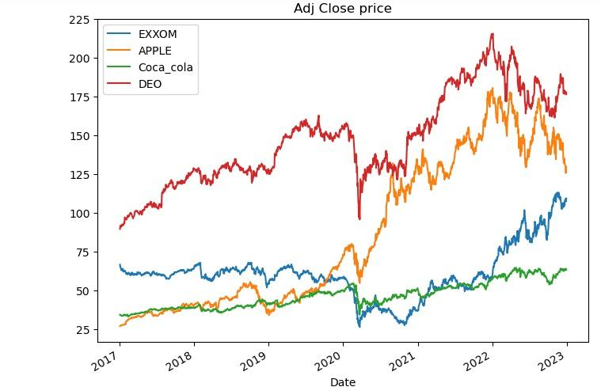

## Cumulative return graph

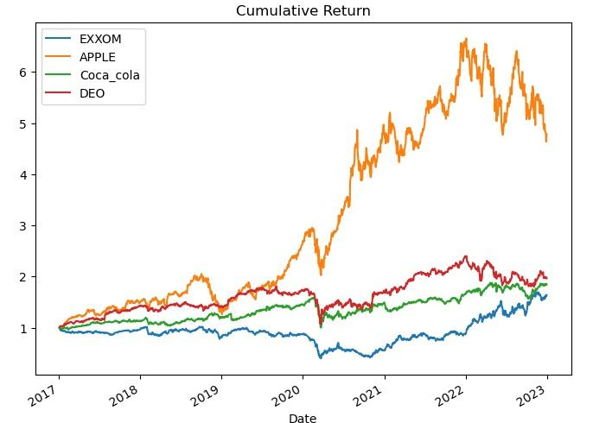

# 2. Metodology

### 2.1 Markowitz portfolio theory

Markowitz's portfolio theory, also known as modern portfolio theory, is a financial theory developed by Harry Markowitz in the 1950s. The theory focuses on building optimized investment portfolios that maximize the expected return on investment. while minimizing risk.

According to Markowitz's theory, the risk of an investment is not simply measured by the volatility of return, but by the correlation of returns between the different assets in the portfolio. Diversification is considered important because it reduces risk through the inclusion of assets with different levels of correlation. Markowitz's theory uses statistical tools to build an optimal portfolio that maximizes expected return and minimizes risk.

Markowitz's portfolio theory has been highly influential in modern investing and has been widely adopted by investors, asset managers, and financial institutions. The theory has been used to develop sophisticated portfolio management techniques and to inform investment decision making around the world.

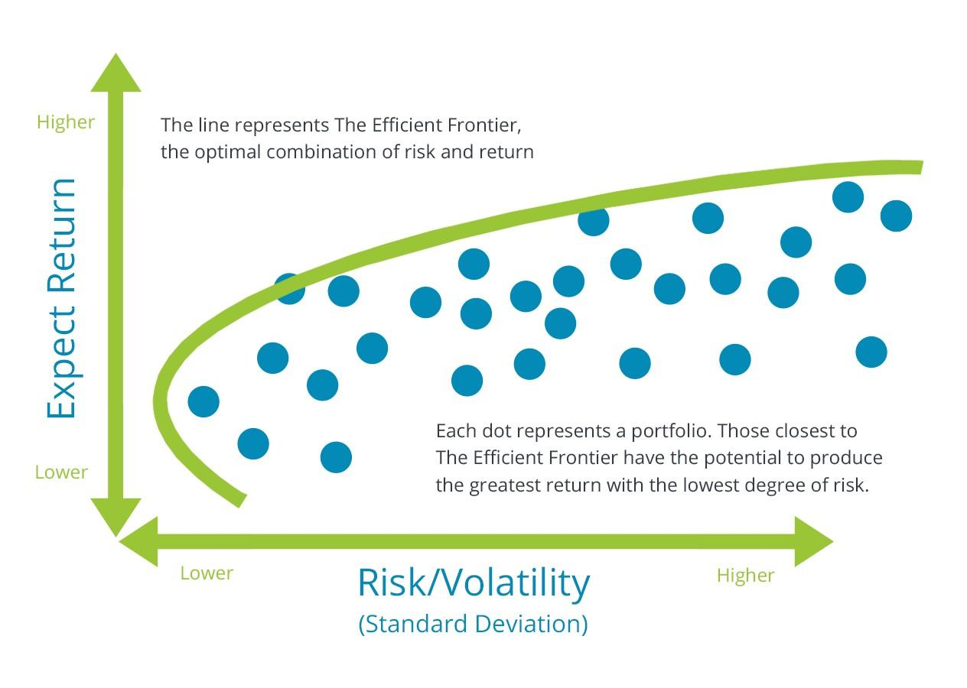

**2.2 Montecarlo simulation**

MonteCarlo simulation is a computer simulation technique used to model complex systems and estimate the probability of uncertain outcomes. The technique is used in a variety of fields, including physics, engineering, economics, statistics, and finance.

MonteCarlo simulation is based on the generation of multiple random samples to model a complex situation. Each sample is processed using a mathematical model, and the results are recorded. The results from all the samples are then combined to obtain a probability distribution for the model results.

MonteCarlo simulation is used in finance to model the behavior of the stock market and estimate the risk and return of an investment portfolio. It is also used in engineering to model complex systems and evaluate performance under different load conditions.

# 3. Results

### 3.1 Random allocation example

With the Monte Carlo simulation we will find 500,000 portfolios with different percentages of each stocks of the total portfolio and we will be left with the one that maximizes the return at the lowest risk. But first, we will show a case of a portfolio without optimizing (Random allocations for each stock) and then we will see how the situation improves if we optimize it.

Let's pretend we had the following random allocations for our USD 1000000 total portfolio:

* 45% in XOM
* 5% in APPLE
* 40% in Coca cola
* 10% in DEO

Our return was 92.8%

Our average daily return was 0.0005%

Our std daily return was 0.012

our annualized sharpe ratio was 0.66

## Graph of the accumulated return of the portfolio with the random allocations

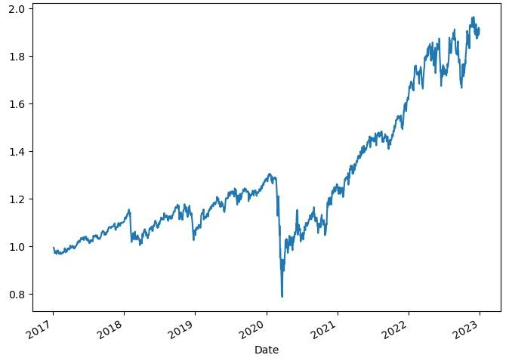

**3.2 Portfolio optimization**

After running the montecarlo simulation (to see the technical details, check the notebook with the code) we find that the approximate optimal allocation for each stock is:

* 0,2% in XOM
* 62,8% in APPLE
* 21,5% in Coca cola
* 15,5% in DEO
* the max average annual return found of portafolio is 20.3%
* the max annual volatility of portafolio found is 0.23
* the max sharpe ratio found is 0.85
* the max return found of the portafolio in the analized period is 101.9%

We can see that both the return per period and the sharpe ratio increased significantly after the optimization.

**Graph of all the simulated and optimal portfolio**

The red dot represents the optimal portfolio.

